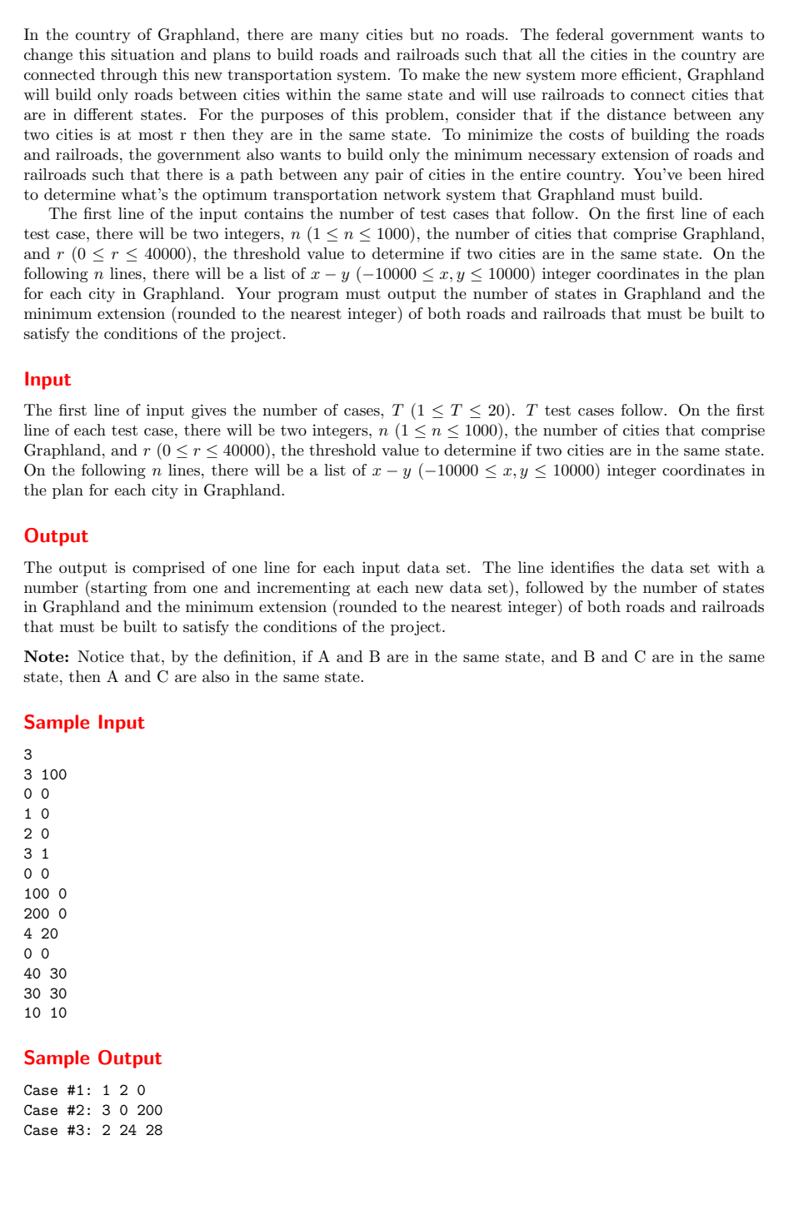
Problem No:
Problem Statement:
Codes:
#include <bits/stdc++.h>
using namespace std;

const int MAXN = 1005;

struct Point {
int x, y;
Point() {}
Point(int x, int y) : x(x), y(y) {}
};

int par[MAXN];

int findrep(int r) {
if (par[r] == r) return r;
return par[r] = findrep(par[r]);
}

void Union(int a, int b) {
int u = findrep(a);
int v = findrep(b);
if (u != v) par[u] = v;
}

double distance(const Point& a, const Point& b) {
int dx = a.x - b.x;
int dy = a.y - b.y;
return sqrt(dx*dx + dy*dy);
}

double primMST(const vector<Point>& points) {
int n = points.size();
if (n <= 1) return 0.0;

vector<double> key(n, 1e18);
vector<bool> inMST(n, false);
key[0] = 0.0;
double sum = 0.0;

for (int cnt = 0; cnt < n; cnt++) {
int u = -1;
double min_key = 1e18;
for (int i = 0; i < n; i++) {
if (!inMST[i] && key[i] < min_key) {
min_key = key[i];
u = i;
}
}
if (u == -1) break;
inMST[u] = true;
sum += min_key;

for (int v = 0; v < n; v++) {
if (!inMST[v] && v != u) {
double d = distance(points[u], points[v]);
if (d < key[v]) {
key[v] = d;
}
}
}
}

return sum;
}

int main() {
int T;
cin >> T;
for (int t = 1; t <= T; t++) {
int n, r;
cin >> n >> r;
vector<Point> cities(n);
for (int i = 0; i < n; i++) {
cin >> cities[i].x >> cities[i].y;
}

for (int i = 1; i <= n; i++) par[i] = i;

for (int i = 0; i < n; i++) {
for (int j = i + 1; j < n; j++) {
double d = distance(cities[i], cities[j]);
if (d <= r) {
Union(i + 1, j + 1);
}
}
}

map<int, vector<Point>> states;
for (int i = 0; i < n; i++) {
int root = findrep(i + 1);
states[root].push_back(cities[i]);
}

int K = states.size();

double road_cost = 0.0;
for (auto& entry : states) {
road_cost += primMST(entry.second);
}

map<pair<int, int>, double> state_edges;
for (int i = 0; i < n; i++) {
for (int j = 0; j < n; j++) {
if (i == j) continue;
int s_i = findrep(i + 1);
int s_j = findrep(j + 1);
if (s_i != s_j) {
double d = distance(cities[i], cities[j]);
int s1 = min(s_i, s_j);
int s2 = max(s_i, s_j);
pair<int, int> key = {s1, s2};
if (state_edges.find(key) == state_edges.end() || d < state_edges[key]) {
state_edges[key] = d;
}
}
}
}

vector<pair<double, pair<int, int>>> edges;
for (auto& entry : state_edges) {
edges.push_back({entry.second, entry.first});
}
sort(edges.begin(), edges.end());

double rail_cost = 0.0;
if (K > 1) {
map<int, int> par_state;
for (auto& entry : states) {
par_state[entry.first] = entry.first;
}

int count = 0;
for (auto& edge : edges) {
double d = edge.first;
int s1 = edge.second.first;
int s2 = edge.second.second;

int u = s1;
while (par_state[u] != u) u = par_state[u] = par_state[par_state[u]];
int v = s2;
while (par_state[v] != v) v = par_state[v] = par_state[par_state[v]];

if (u != v) {
par_state[u] = v;
rail_cost += d;
count++;
if (count == K - 1) break;
}
}
}

int road_rounded = round(road_cost);
int rail_rounded = round(rail_cost);

cout << "Case #" << t << ": " << K << " " << road_rounded << " " << rail_rounded << endl;
}

return 0;
}

Output:
